The selected flooring similar to Dancefloor must be available in 2m wide roll.

The product formulation **does not contain phthalate-based plasticizer.** It is built on a calendared backing layer made of recycled vinyl flooring material. It contains over **25% recycled material.**

The vinyl floor covering is reinforced with a non-woven fiber glass mat combined with a high density closed-cell foam. The foam backing must be deeply embossed to reinforce the suction effect. The product **should have a specific surface embossing “dance” for optimal grip.**

The total thickness should be at least equal to 3.45mm.

The product should offer resistance to **static indentation lower than 0.18mm** and **vertical deformation lower than 0.8mm.**

It offers a **dimensional stability lower than 0.10%** according to EN ISO 23999**.**

The **fire resistance** according to EN13501-1 should be at least **Cfl-s1.**

The product should be **100% recyclable.** The clean off-cuts can be collected, recycled and reused in the production of vinyl floor coverings through Restart® program or similar.

In alignment with the goal of eliminating substances that may have adverse effects on users’ health and the environment, **biocide-free products should be prioritized.**

The selected product must be **REACH compliant.**

Product **warranty should be equal or superior to 10 years.**

The installation should be performed in accordance with **local requirements** and in conformity with **manufacturer’s installation guide recommendations.**

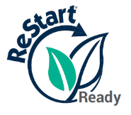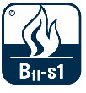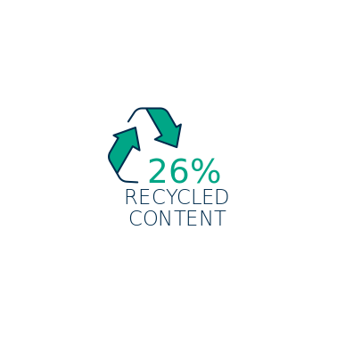

**Available documentation & certificates**

* Technical datasheet
* Multi-language DoP (Declaration of Performance)
* Reaction to fire test report
* Thermal resistance EN ISO 10456
* Installation and maintenance guides

**Environmental certificates**

* Eurofins VOC emissions report

**Contact us**

**For any additional information, Tarkett Sports experts remain at your disposal to assist you throughout your project.**

[info.tarkettsports.indoor@tarkett.com](mailto:info.tarkettsports.indoor@tarkett.com)  
 [eu.tarkettsportsindoor.com](https://eu.tarkettsportsindoor.com/fr/)