The selected flooring similar to Omnisports Reference *Multi-use* must comply with **EN 14 904 standard requirements and is classified P1,** available in 2m wide roll.

The product formulation **does not contain phthalate-based plasticizer.** It is built on a calendared backing layer made of recycled vinyl flooring material. It contains over **21% recycled material.**

The sports vinyl floor covering is reinforced with a non-woven fiber glass mat combined with a high density closed-cell foam. The foam backing must be deeply embossed to reinforce the suction effect.

The **wear layer** is reinforced with UV photo-crosslinked polyurethane Top Clean XP™ applied in factory. The product must offer the **same top embossing between solid and wood designs.**

The total thickness should be at least equal to 6.2mm.

The product should offer resistance to **static indentation lower than 0.10mm** and **vertical deformation lower than 2mm.** Itshouldoffer **ball rebound at least equal to 95%.**

It offers a **dimensional stability lower than 0.10%** according to EN ISO 23999**. The resistance to wear should be <0.2g** accordingtoENISO5470-1**.**

The **fire resistance** according to EN13501-1 should be at least **Cfl-s1.**

The product must not **trigger any disease related to asthma and allergy** and should be covered by the **Seal of Approval delivered by Allergy UK standard**.

Its emission rate of volatile organic compounds in air is very low, measured after 28 days according to EN standard 16516. Close to zero emission (quantification limit), **TVOC, TSVOC and formaldehyde emissions are below 10 µg/m3.**

In alignment with the goal of eliminating substances that may have adverse effects on users’ health and the environment, **biocide-free products should be prioritized**.

The product should be **100% recyclable.** The clean off-cuts can be collected, recycled and reused in the production of vinyl floor coverings through Restart® program or similar.

The selected flooring is covered by a specific third-party verified **Environmental Product Declaration (EPD),** disclosing among other indicators the carbon footprint of the flooring during its whole lifecycle.

The selected flooring is covered by a third-party verified **ingredient disclosure and material risk declaration down to 0.01%w**, thus **ensuring compliance far beyond REACH regulation requirements**, such as **Material Health Statement (MHS).**

Product **warranty should be equal or superior to 15 years.**

The installation of the vinyl sports flooring can be implemented using **perimeter glue method – minimum 90% adhesive-free, on** a subfloor with **humidity rate up to 7%.** Above this rate the subfloor is considered saturated.(See the manufacturer’s installation guide)

The product should be recommended by the international federations of **Basketball - FIBA**

**Available documentation & certificates**

* Technical datasheet
* Multi-language DoP (Declaration of Performance)
* EN 14904 certificate of compliance
* Reaction to fire test report
* Dimensional stability certificate (internal)
* Wear layer thickness certificate (internal)
* Acoustic efficiency report EN ISO 717-2
* Thermal resistance EN ISO 10456
* Installation and maintenance guides
* FIBA certificate

**Environmental certificates**

* Tarkett Indoor Air Quality certificate
* Eurofins VOC emissions report
* Allergy UK Seal of Approval
* MHS – Material Health Statement
* EPD – Environmental Product Declaration

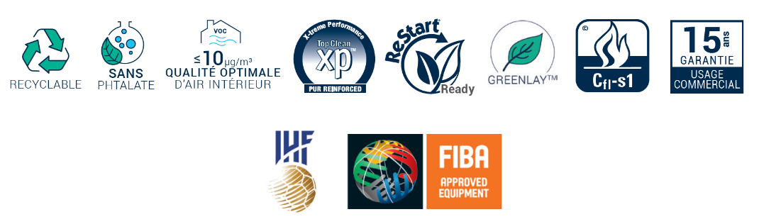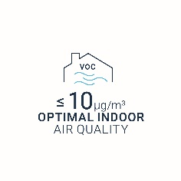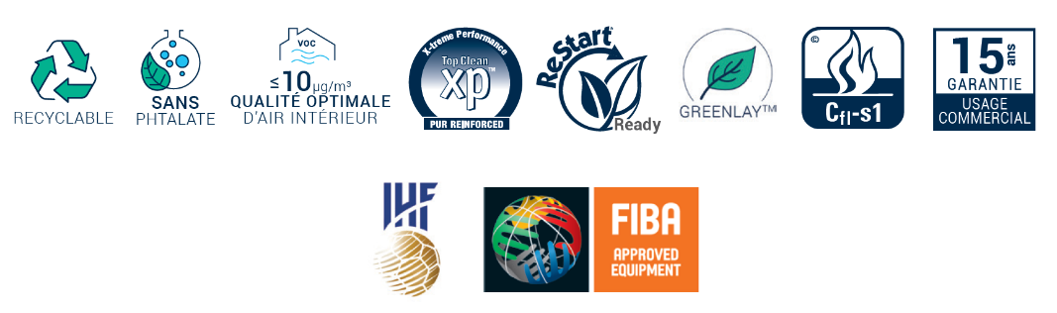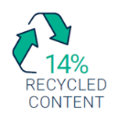

**Contact us**

**For any additional information, Tarkett Sports experts remain at your disposal to assist you throughout your project.**

[info.tarkettsports.indoor@tarkett.com](mailto:info.tarkettsports.indoor@tarkett.com)  
 [eu.tarkettsportsindoor.com](https://eu.tarkettsportsindoor.com/fr/)